**Assignment 5 – Part 2  
p305 Set 5.4 - 2, 10**

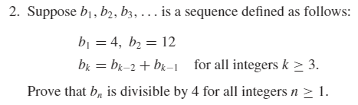

**2.) Let $P\left(n\right)$ be $b_{n}=b_{n-2}+b_{n-1}$ is divisible by 4 for all integers $n≥1$  
Show that P(0) and P(1) are true:  
P(0)=4, which is divisible by 4 because 4 = 4\*1  
P(1)=12, which is divisible by 4 because 12 = 4\*3  
Suppose $P(i)$ is divisible by 4 for all integers $i$ from 1 through $k$: $b_{i}=b_{i-2}+b_{i-1}$ 
 is divisible by 4 for all integers $i$ with $1≤i≤k$  
By definition of divisibility $b_{i-2}+b_{i-1}=4r$ 
 where $r$ is some integer.  
We must show that $b_{k+1}=b_{k-1}+b_{k}$ 
 is divisible by 4  
By substitution $$b_{k+1}=b_{k-1}+4r$$ 
By our assumption we know that $b_{k-1}$ is also divisible by 4. Thus by substitution $$b_{k+1}=4r+4r \\ b_{k+1}=4(2r)$$ 
Thus we have shown that $b_{k+1}$ is divisible by 4. Since we have proved the basis step and the inductive step, we conclude that the proposition is true.**

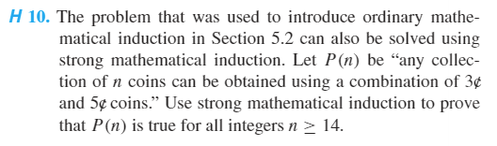

**10.) Show that $P\left(14\right), P\left(15\right), and P\left(16\right)$ are true: $$P\left(14\right)=3₵+3₵+3₵+5₵ \\ P\left(15\right)=5₵+5₵+5₵ \\ P\left(16\right)=3₵+3₵+5₵+5₵$$ 
[Suppose $P\left(k\right)$ is true for a particular but arbitrarily chosen integer $k≥14$. That is:] $k₵$ 
 can be obtained using 3 $₵$ and 5 $₵$ coins.  
[We must show that $P\left(k+1\right)$ is true. That is:] We must show that $(k+1)₵$ can be obtained using 3 $₵$ and 5 $₵$ coins.  
Case 1 (There is a 5 $₵$ coin among those used to make up the k $₵$.)  
In this case replace the 5 $₵$ coin by two 3 $₵$ coins; the result will be $(k+1)₵$ Case 2 (There is not a 5 $₵$ coin among those used to make up the k $₵$.)  
In this case, because $k≥14$, at least three 3 $₵$ coins must have been used. So remove three 3 $₵$ coins and replace them by two 5 $₵$ coins; the result will be $(k+1)₵$.  
Thus in either case $(k+1)₵$ can be obtained using 3 $₵$ and 5 $₵$ coins [as was to be shown.]**